# CS 255 System Design Document

## UML Diagrams

### UML Use Case Diagram

### UML Activity Diagrams

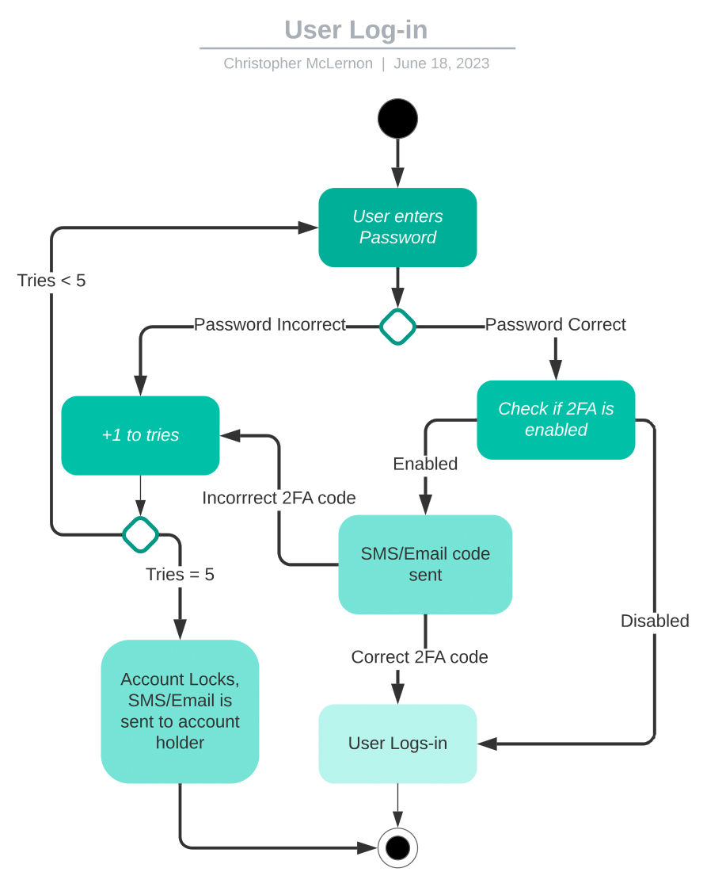

### 

### UML Sequence Diagram

### 

### UML Class Diagram

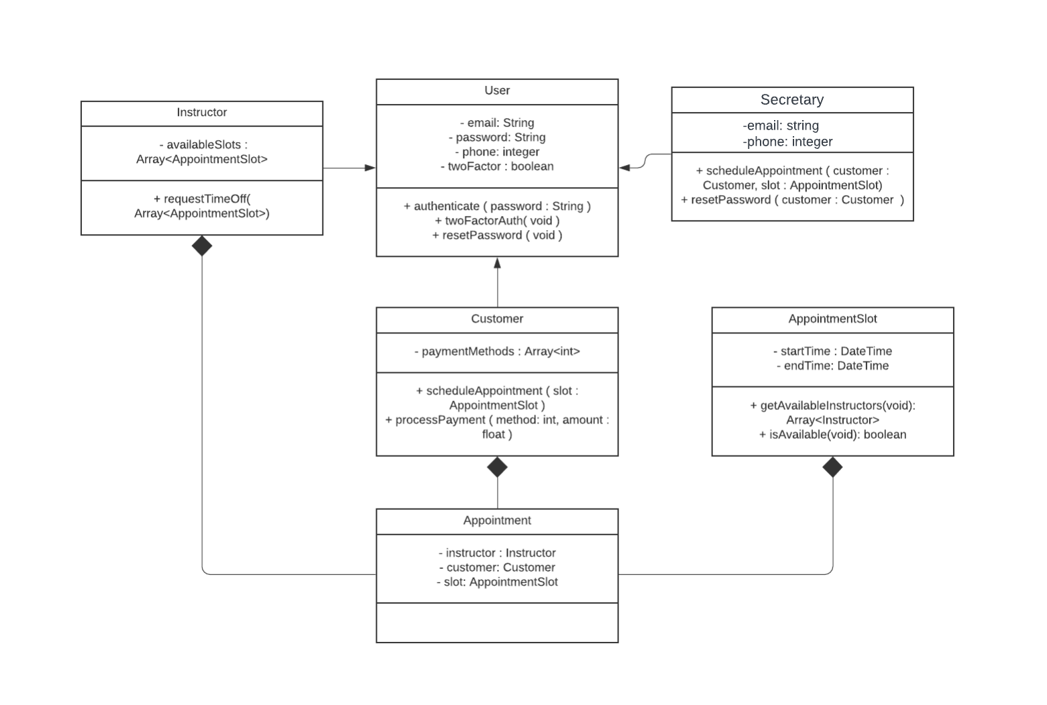

## Technical Requirements

Requirements for running the backend database and web interface:

A host machine with a stable internet connection is essential.

Requirements for the payment processing service:

A computer equipped with a web browser is necessary for using the office interface.

Additional requirement for the payment processing service:

The service should incorporate a 2-factor authentication mechanism for added security.